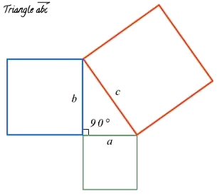

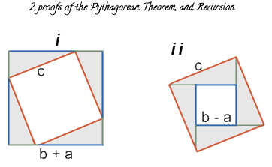

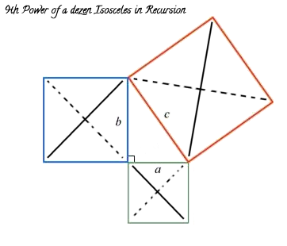

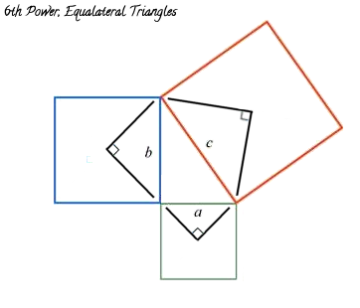

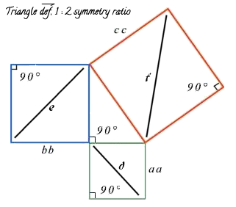

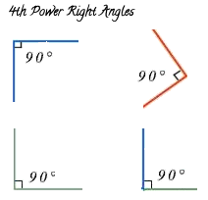

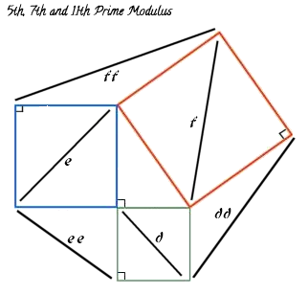

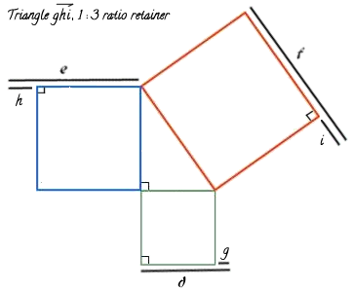

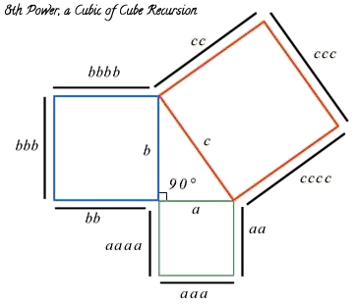

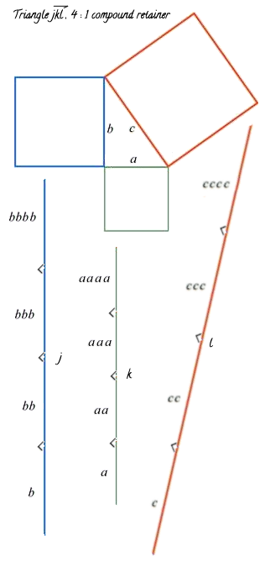

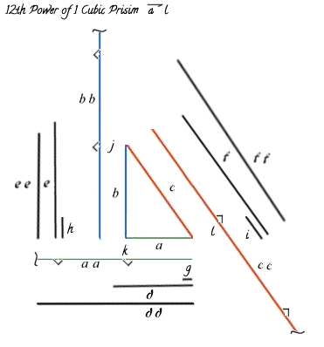

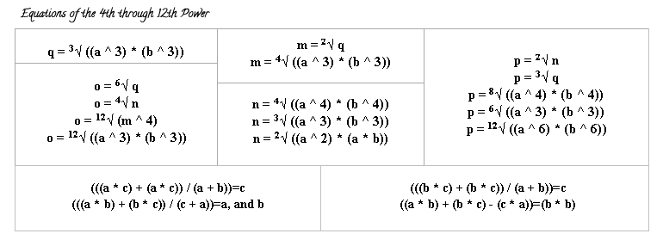

If a=9 and b=9 then the rest is known;

Triangle abc's sides: 9, 9, 12.7279220613579
m=(((a ^ 3) * (b ^ 3)) ^ (1 / 2))=729
n=(m ^ (1 / 2))=27
n=(((a ^ 3) * (b ^ 3)) ^ (1 / 4))=27
o=(((a ^ 3) * (b ^ 3)) ^ (1 / 3))=81
o=(((a ^ 4) * (b ^ 4)) ^ (1 / 4))=81
o=(a ^ 2)=81
o=(a * b)=81
o=(((a ^ 2) * (a * b)) ^ (1 / 2))=81
p=(((a ^ 3) * (b ^ 3)) ^ (1 / 12))=3
p=(m ^ (1 / 6))=3
p=(o ^ (1 / 4))=3
p=((n ^ 4) ^ (1 / 12))=3
q=(((a ^ 4) * (b ^ 4)) ^ (1 / 8))=9
q=(m ^ (1 / 3))=9
q=(o ^ (1 / 2))=9
q=(((a ^ 3) * (b ^ 3)) ^ (1 / 6))=9
q=(((a ^ 6) * (b ^ 6)) ^ (1 / 12))=9

Triangle def's sides: 12.7279220613579, 12.7279220613579, 18
m=(((d ^ 3) * (e ^ 3)) ^ (1 / 2))=2061.92337393997
n=(m ^ (1 / 2))=45.4084064237006
n=(((d ^ 3) * (e ^ 3)) ^ (1 / 4))=45.4084064237006
o=(((d ^ 3) * (e ^ 3)) ^ (1 / 3))=162
o=(((d ^ 4) * (e ^ 4)) ^ (1 / 4))=162
o=(d ^ 2)=162
o=(d * e)=162
o=(((d ^ 2) * (d * e)) ^ (1 / 2))=162
p=(((d ^ 3) * (e ^ 3)) ^ (1 / 12))=3.56762134500816
p=(m ^ (1 / 6))=3.56762134500816
p=(o ^ (1 / 4))=3.56762134500816
p=((n ^ 4) ^ (1 / 12))=3.56762134500816
q=(((d ^ 4) * (e ^ 4)) ^ (1 / 8))=12.7279220613579
q=(m ^ (1 / 3))=12.7279220613579
q=(o ^ (1 / 2))=12.7279220613579
q=(((d ^ 3) * (e ^ 3)) ^ (1 / 6))=12.7279220613579
q=(((d ^ 6) * (e ^ 6)) ^ (1 / 12))=12.7279220613579

Triangle ghi's sides: 3.72792206135786, 3.72792206135786, 5.27207793864214
m=(((g ^ 3) * (h ^ 3)) ^ (1 / 2))=51.8084348499314
n=(m ^ (1 / 2))=7.19780764190955
n=(((g ^ 3) * (h ^ 3)) ^ (1 / 4))=7.19780764190955
o=(((g ^ 3) * (h ^ 3)) ^ (1 / 3))=13.8974028955586
o=(((g ^ 4) * (h ^ 4)) ^ (1 / 4))=13.8974028955586
o=(g ^ 2)=13.8974028955586
o=(g * h)=13.8974028955586
o=(((g ^ 2) * (g * h)) ^ (1 / 2))=13.8974028955586
p=(((g ^ 3) * (h ^ 3)) ^ (1 / 12))=1.93078275871675
p=(m ^ (1 / 6))=1.93078275871675
p=(o ^ (1 / 4))=1.93078275871675
p=((n ^ 4) ^ (1 / 12))=1.93078275871675
q=(((g ^ 4) * (h ^ 4)) ^ (1 / 8))=3.72792206135786
q=(m ^ (1 / 3))=3.72792206135785
q=(o ^ (1 / 2))=3.72792206135785
q=(((g ^ 3) * (h ^ 3)) ^ (1 / 6))=3.72792206135785
q=(((g ^ 6) * (h ^ 6)) ^ (1 / 12))=3.72792206135785

Triangle jkl's sides: 36, 36, 50.9116882454314
m=(((j ^ 3) * (k ^ 3)) ^ (1 / 2))=46656
n=(m ^ (1 / 2))=216
n=(((j ^ 3) * (k ^ 3)) ^ (1 / 4))=216
o=(((j ^ 3) * (k ^ 3)) ^ (1 / 3))=1296
o=(((j ^ 4) * (k ^ 4)) ^ (1 / 4))=1296
o=(j ^ 2)=1296
o=(j * k)=1296
o=(((j ^ 2) * (j * k)) ^ (1 / 2))=1296
p=(((j ^ 3) * (k ^ 3)) ^ (1 / 12))=6
p=(m ^ (1 / 6))=6
p=(o ^ (1 / 4))=6
p=((n ^ 4) ^ (1 / 12))=6
q=(((j ^ 4) * (k ^ 4)) ^ (1 / 8))=36
q=(m ^ (1 / 3))=36
q=(o ^ (1 / 2))=36
q=(((j ^ 3) * (k ^ 3)) ^ (1 / 6))=36
q=(((j ^ 6) * (k ^ 6)) ^ (1 / 12))=36

